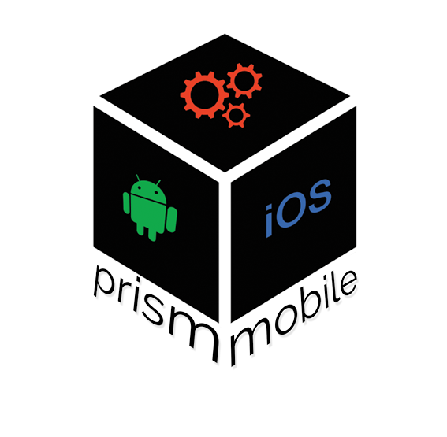

Prism Mobile

15165 Ventura Blvd #245

Sherman Oaks, CA 91406

QUOTE FOR SERVICES

Written for Cost of Redemption Enterprises

Prism Mobile will offer the following services:

* E-mail marketing
  + Create, manage, and send newsletters, announcements, and product advertisements through e-mail to potential clients
  + Cost of e-mail list services is to be covered by Client (Aweber is preferred)
  + Cross and affiliate marketing of other companies’ products and services (Prism Mobile takes 20% of affiliate revenue)
* Copywriting Services
  + Professional Copywriting and text marketing on any avenue of content including but not limited to e-mail, blog posts, video marketing,
* Webmaster Services
  + Website Maintenance
  + HTML, CSS, Javascript, and PHP coding
  + Responsive design testing and coding
  + WordPress editing, design, and backup via Git
  + Front/Back end system architecture design and MySQL database management
  + Site reliability engineering and management
* Marketing
  + Copy split testing and sales funnel/lead generation optimization
  + Google Analytics optimization
  + Manage Pay Per Click or Search Engine Marketing campaigns
  + Website heat mapping to track user interaction
* Search Engine Optimization for Blog Posts
  + Target keywords for search engines
  + Add/edit SEO titles and descriptions of blog posts
  + Utilize latest SEO tools in specification with current practices (Google Engineers available as references)
* Content Creation
  + Blog post creation
  + Ghost writing for authors
  + Video editing via Adobe Premiere and After Effects CC

All services offered are available at $600/month, maximum of 10 hours per month. Additional hours may be purchased at the standard rate of $75/hour. Minimum 6 month commitment via retainer contract.

Your Chief Engineer: Ben Junya

Your Marketing Manager and Analyst: Ben Junya

ABOUT PRISM MOBILE

At heart, we are UX designers, with side experience creating mobile and web applications. Tech is our specialty, whether it’s on the web, on your phone, your tablet, your TV, your watch, or glass display, wherever you need information in the quickest and most direct manner.

With a specialty in wearable technology and mobile applications, Prism Mobile offers businesses from startups to large companies the absolute best in web development, marketing, and web maintenance work. We are an independent Google Technologies Developer, and have worked with senior engineers from multiple tech companies like Google, Intel, GlassDoor, and Texas Instruments.

User Experience is our Business.

Thank you for choosing Prism Mobile as your Web/Android/iOS developer. We take pride in offering a high quality User Experience oriented design principle, and we hope you enjoy your new website. Feel free to contact me at anytime via phone at 815-713-6001, or send me an email at ben@prism-mobile.com

TERMS AND CONDITIONS:

This quote is valid until Midnight PST 8/24/14. Prism Mobile reserves the right to cancel the retainer agreement at any time. We understand not all services will be needed, but the services listed here are available for your use. Additional costs to client not covered by Prism Mobile include e-mail marketing platforms, web hosting, MySQL server hosting, mobile application publishing fees, and domain registration services, .

3 month upfront payment required upon start of services. Afterwards, services are paid on a month-to-month basis. Prism Mobile reserves the right to change the cost of services within 104 days of client acknowledgement.

Services are paid and provided for via contractual terms, and payment for services does not guarantee results.